**Screenshots of memory game**

**By:**

**Mohamed alaoui mhamdi**

**Ayoub Adnane**

**First interface menu :**

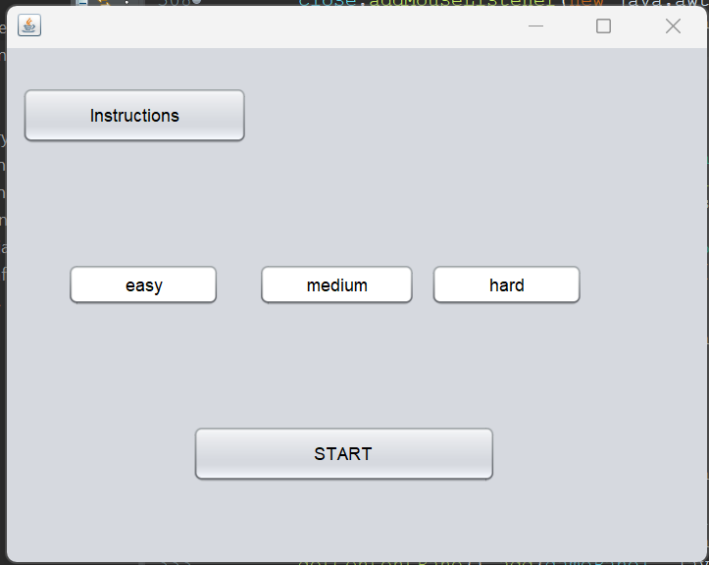

1.Easy

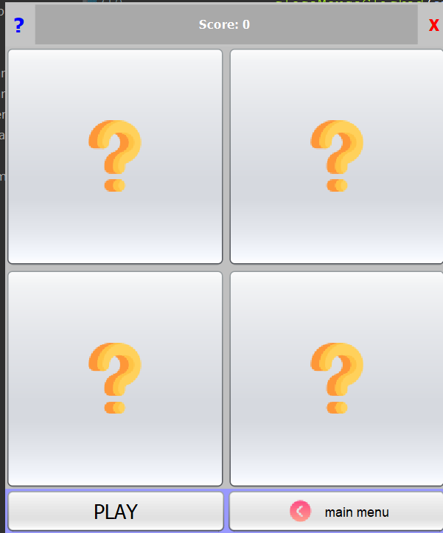

2.medium

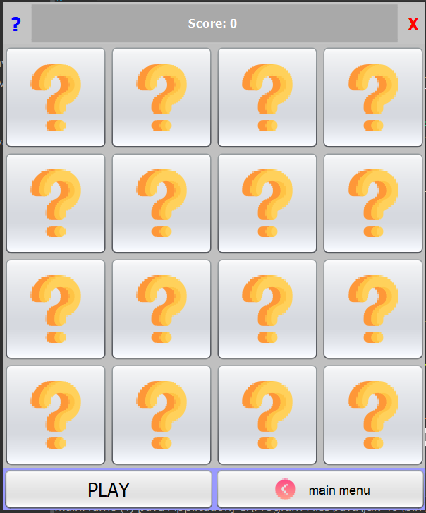

3.hard

